AZ PARENTS, YOUTH, COMMUNITY 360Rx OVERVIEW

Parents, Youth and Community 360Rx is a key component of Strategy 4. The community presentations contained in the program were developed from lessons learned during the Rx Misuse and Abuse Initiative pilot sites and from The Partnership for Drug-Free Kids PACT360 suite of educational presentations. The AZ Parents, Youth and Community 360Rx provides power point presentations, discussion guides, videos, educational handouts and a parent talk kit to help raise awareness of prescription drug misuse, encourage proper storage and disposal of medications and to provide parents and grandparents with tools to build resiliency in their children.

Parents 360Rx is an evidence informed prevention program that engages parents, grandparents and caregivers through an interactive presentation. The hour-long presentation provides parents and other caring adults with valuable insights as to why children and teens abuse prescription drugs, how parents can start the dialogue about the dangers of prescription drug misuse with their children and how parents can build resiliency in their children to turn down offers to try prescription and other drugs. The presentation features a powerful video where parents share their personal stories of how prescription drug misuse impacted their lives. It underscores the need for parents to educate themselves about the dangers of prescription drugs, and to be the go-to source when their children have questions or need help.

Youth 360Rx has activities targeted to middle school and high school students and include the following elements.

Middle School – This program targets children in grades 6-8. Youth 360Rx for middle school explores the child’s perceptions about drugs & prescription drugs. The 50 minute classroom activity helps a child understand that misusing a prescription medication can be just as dangerous, addictive and deadly as using a street drug like heroin. The middle school students then learn the myths and facts about prescription drug misuse. The class lesson ends with an activity where the child writes a letter to a friend about why they should not take prescription medication not prescribed to them by a doctor.

High School – The High School activity is targeted to youth in grades 9-12. Just like the middle school lesson, the high school lesson includes the initial perceptions about drugs and prescription drugs. The high school program then features an 11 minute high impact video showing how drugs and prescription drugs directly affects young users. After the video, the youth then play an interactive game where they must make choices based on real-life scenarios. The program provides the opportunity for teens to fully reflect upon the choices and consequences associated with prescription drug abuse and to continually keep themselves and their friends in check.

Community 360Rx – There may be instances where the Parents 360Rx does not fit the target audience. In order to serve more community members, Community 360Rx was developed. This presentation is designed for coalitions and community organizations that would like to present information about prescription drug misuse to the general public. It is not parent specific. It is focused on the problem of prescription drug misuse, safe storage of prescription drugs and safe disposal of medications. This presentation is ideal for community organizations like Kiwanis, Rotary or Realtor association meetings.
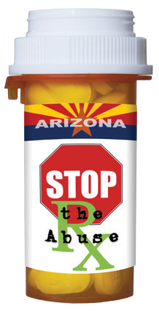
Spanish and Older Adults 360Rx (Rx Matters) has activities targeted toward the Spanish speaking population as well as for the older adult population.

Training for the AZ Parent, Youth and Community 360Rx is a half day. Please complete the training
request on www.rethinkrxabuse.org to schedule a training.

